About the ABC Rating System
Contents
What is a Threat Factor? 1
Where Do Threat Factors Come From? 2
Assigning Threat Factors Using Tunnel Testing 2
Assigning Threat Factors Without a Tunnel Test 5
Appendix I. Definitions 6
Appendix II. The BirdVis App: Avian Visual Contrast Levels 7
Appendix III. 8
Assigning Threat Factors via Prescriptive Rating Option 8
References 11

What is a Threat Factor?
It is difficult to objectively define what makes glass “bird-friendly.” Although used frequently, the term ‘bird-friendly’ itself provides no specific guidance. Architects interested in designing a building that does not kill birds can select products for their insulation value, breaking strength, or a host of other characteristics, but until recently there was no system for specifying bird-friendly materials. Making analysis more difficult, the quality of being bird-friendly is more complex than a quality like insulation value because birds respond to the appearance of glass and this can vary dramatically for a single product as seen in the changing light of day, as well as under artificial light at night. Additional complexities such as IGU build, façade or freestanding installation, differing reflected environments and other factors make each situation unique. Contributing factors vary so much that an absolute measurement cannot be provided.
In 2010, experts from American Bird Conservancy and a team of architects interested in advancing the field of bird-friendly design developed the concept of Threat Factor (TF). This is a way to assign scores that provide a relative measure of how well materials with patterns of visual markers cause avoidance by birds in a standard, controlled test environment. These scores allow architects to use collision deterrence as a factor when designing buildings. The system also permits evaluation of products that can be applied to existing glass (retrofits). TFs also made it possible to create a credit for reducing bird collisions in the LEED rating system and have now begun to be included in legislation, like New York City’s Local Law 15 of 2020.

Where Do Threat Factors Come From?
Ideally, Threat Factors could be derived from monitoring collisions on glass at a collection of diverse, existing buildings, replacing that glass with a product under review, continuing to monitor to see whether collisions are reduced and calculating the reduction. Unfortunately, this type of data is very rare and this type of test would be very costly. It would also take years to acquire enough monitoring data to reliably detect a trend for a single product and, importantly, it would kill birds. ABC realized the need to create practical ways to evaluate glass. Initially, TFs were derived only from a tunnel test (described below). More recently, data from field trials and other types of testing have been factored in.

Assigning Threat Factors Using Tunnel Testing
In 2003, Martin Rössler and Thomas Zuna-Kratky (2004) created the first “tunnel” at the Hohenau-Ringelsdorf Biological Station (Austria), to test proposed solutions to bird collisions on freestanding noise barriers. ABC's tunnels, using a second-generation design (Rössler et al., 2007), followed in 2009 and 2021. Tunnel testing is a non-injurious, standardized binomial choice technique that uses wild songbirds to determine the relative effectiveness of different patterns of visual markers at deterring bird collisions. In the U.S., tunnel testing takes place at American Bird Conservancy's tunnel at either the Carnegie Museum of Natural History's Powdermill Avian Research Center or at Washington College’s Foreman’s Branch Bird Observatory .
In a test flight, a bird flies down a completely dark space, the ‘tunnel' (Figure 1), toward light at the far end, where side-by-side panels of glass appear to offer exit routes (Figure 2). One of these panes of glass is clear, unmarked glass (the control, invisible to the bird) and the other has the pattern of visual markers under evaluation (the test pane). A net ensures that the bird is safely stopped before it can hit the glass. After one trial, the bird is immediately released. When few birds fly to the patterned glass, we believe that they see and are avoiding the visual markers. For a detailed description of the Powdermill and Hohenau tunnels, see Sheppard (2019) and Rössler et al. (2007).
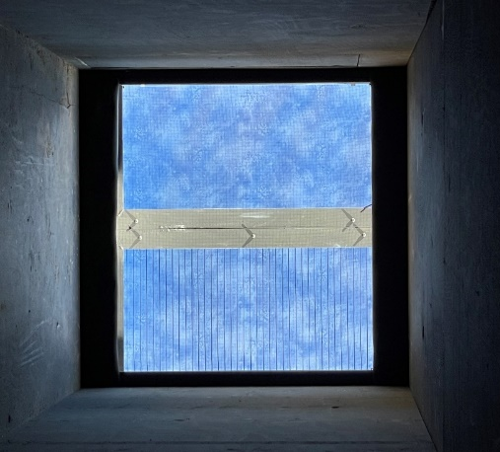
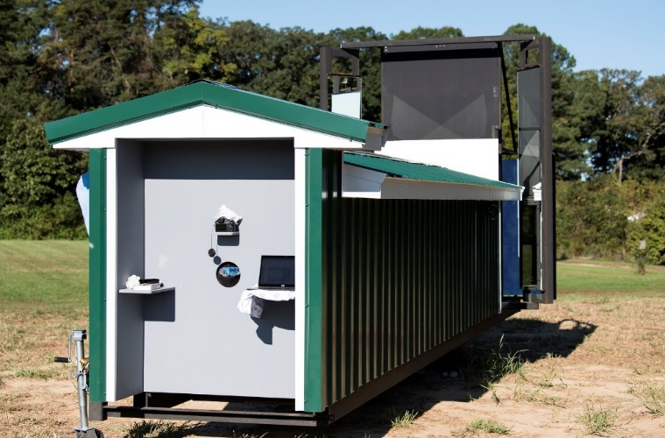

Figure 1. Test Tunnel at Foreman’s Branch Figure 2. View of glass samples
Specimen Performance Index (SPI) of a material is calculated by flying at least 80 individual birds down the tunnel and recording the percent that fly toward the test pane. For example, suppose 80 birds flew down the tunnel, with 20 flying toward the test pattern and 60 toward the control. 25% (20/80) of the birds flew toward the test pattern and it would have SPI of 25. If there is no additional information, for example, from a field trial, then the TF is equal to the SPI.

Important considerations
- SPIs and TFs do not warranty the actual percent reduction in collisions to be expected when a product is installed on a building. In fact, the same product may perform better or worse due to facade orientation in the same building, façade detail creating traps or channels, habitat reflected, whether the glass is free-standing and other variables. Threat Factors are an index, measuring the relative response to different patterns and different glass builds by songbirds flown in the tunnel. However, where monitoring data on tunnel-tested products are available, they confirm that products with lower threat factors yield fewer collisions. ABC defines “bird-friendly” materials as having a threat factor ≤ 30, corresponding to a conservative estimated reduction of collisions of at least 50% under real world conditions.
- The lower the Threat Factor, the more effective the tested material will be at reducing collisions. This has been confirmed when data is available. However, the relationship between TF score and effectiveness does not appear to be linear, so one cannot say that a pattern with TF=15 is twice as effective as a pattern with TF=30.
- Strong reflections can reduce pattern effectiveness by obscuring the visual markers during part or all of the day, if the pattern is on an inside surface of the glass. Reflections vary with insolation and with the angle of view, from the strongest reflections at acute angles to the weakest reflections when glass is viewed head on (Figure 3)

Figure 3: A single piece of glass with frit on surface 2, viewed head on (left) and from the side (right): The reflection is much stronger at an acute angle than it is head on. This glass has a surface reflectivity < 14%. However, for a bird to view this glass at an angle where there is a dangerous reflection, it would be flying almost parallel to the glass surface, where a collision would be unlikely to cause injury.
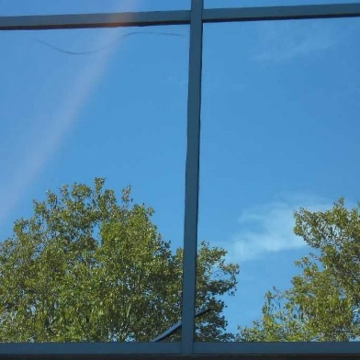
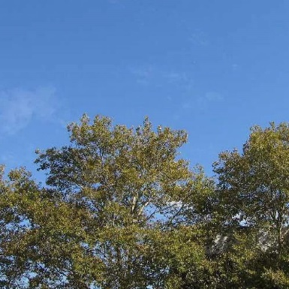
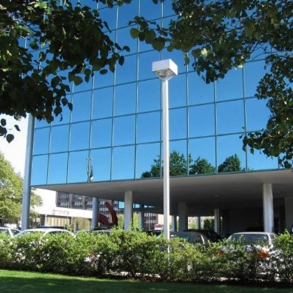
- ABC's tunnel test cannot replicate the range of possible reflections on a glass sample, so our tests model situations where a pattern is visible against a competing view. In the tunnel, birds see visual markers against a complex background (seen in figure 2), modeling situations where either the glass has only a moderate reflection or when birds can see through the glass to a landscape beyond. While it might seem at first that “reflection” and “see-through” conditions are quite different, in this context they are similar. In figure 4a, below, we cannot determine whether the image is a photo of a tree, a tree seen through a window, or the reflection of a tree. With the information in 4b, showing mullions, a crack, and right angles, we know glass is involved, but only with the information in figure 4c can we confirm that the image is a reflection and that we are not looking out the window at trees.

Figure 4a. 4b. 4c.
- ABC does not test materials with greater than 15% reflection (VLR) at the exterior surface of the glass, unless the visual markers are on the outside surface, or our BirdVis app (see appendix II) shows that there is sufficient contrast for markers to show through reflections.
- Because reflections on glass are both site and product specific, reflections should be considered early in the design process. Recommended design phase analysis ideally involves samples of glass viewed on the project site from a variety of angles, at different times of day, and with all potential site-specific reflections taken into consideration.

Spacing of Visual Markers
Where early recommendations, based on research by Klem (1990) and Rössler et al. (2007), showed that horizontal lines spaced 2” (5cm) apart and vertical lines spaced 4” (10cm) apart significantly reduced collisions, subsequent monitoring showed that the 4” spacing does not stop collisions by the smallest birds, especially hummingbirds. The spacing guideline for the Prescriptive Rating Option assigns a lower score when there is 2” (5 cm) spacing between the pattern’s visual markers vertically and horizontally and a higher score for patterns with 4” (10 cm) horizontal spacing. Two inch (5 cm) spacing for two-dimensional patterns on glass or window film is now typically recommended in Canada (Canadian Standard A460) and increasingly in the United States. Thus, what was once the ‘2x4 rule’ is now the ‘2x2 rule’. However, 2x4” spacing has been demonstrated to reduce collisions significantly and materials based on that guideline can still receive a ‘bird-friendly’ TF rating.

Visual Acuity
For a pattern of visual markers on glass or other materials to successfully deter bird collisions, birds must be able to perceive it in time to change course. The pattern of visual markers must be of an appropriate size and spacing and must be distinguishable from the both glass and any reflections or the view through the glass (e.g., habitat, sky, water, a potential flight path, etc.). We have adopted 9’-9’ ½” (3 meters) as the standard viewing distance from which birds must be able to detect the pattern, following Ros et al. (2017).
Our instinct is to use human vision as a proxy for what birds can see. However, birds can see more colors and even perceive the earth’s magnetic field, while humans have much better visual acuity. ‘Visual acuity’, the ability to resolve spatial features depends on the size of the eye and the number of photoreceptors in the retina. Songbird eyes are much smaller than human eyes. Because of this, birds, particularly small birds like songbirds, have very poor visual acuity in comparison to humans. Therefore, a pattern that appears quite visible to us may not be apparent at all to birds (Caves, Brandley and Johnsen, 2018).

Ultraviolet Patterns

Products with UV patterns should be considered carefully for some applications: Materials with ultra-violet patterns will vary in effectiveness with the amount of UV light present. This means that when the UV index is low – under low light conditions in early morning or evening or if the glass is shaded, or when it is overcast – UV patterns will be less visible to birds. In addition, not all types of birds can see UV. For example, songbirds can see UV, raptors and pigeons cannot.

Assigning Threat Factors Without a Tunnel Test
Not all materials need to be tunnel tested, specifically materials that are similar to others previously tested. ABC partners with the Bird-Safe Buildings Alliance (BSBA), a group of architects experienced in bird-friendly design, conservation biologists, and others with collisions expertise, to provide TFs for materials similar to those already rated. These ratings are very conservative: the rating assigned is the maximum expected TF; lower ratings might be obtainable through actual tunnel testing.
TFs can be assigned by review, instead of by tunnel test, to products that: a) were tested using other, peer-reviewed protocols that ABC and BSBA have determined to be equivalent or translatable to tunnel testing scores, b) were studied by scientists or experienced building collision monitors with a documented reduction in collisions of at least 50%, or c) comply with ABC's Prescriptive Rating Option (Appendix III). The Prescriptive Rating Option describes only a subset of materials that can be rated by other methods.

Appendix I. Definitions
Acid Etch: the use of hydrofluoric acid on glass to create translucent visual markers with texture and a ‘frosted’ appearance.
Exterior Visible Light Reflection (VLR): Net Exterior (measured at surface 1) reflection of complete glass build, including any coatings, (for the purpose of the prescriptive rating option, the VLR excludes visual markers)
Gloss reading of markers (60°): Please see ASTM D523 Standard Test Method for Specular Gloss
Opaque: Visible Light Transmission (VLT) = 0
Pattern: Spatial arrangement and dimensions of visual markers on glass.
Visual Contrast: A difference in visual appearance of two surfaces sufficient for birds to distinguish between the two surfaces.

Appendix II. The BirdVis App: Avian Visual Contrast Levels
Because human perception is unreliable for evaluating what is sufficiently visible to birds, the Bird-safe Buildings Alliance contracted for the creation of an app, based on properties of the avian retina and studies of avian visual acuity. The BirdVis app (3.140.67.204:3838 Luro, 2021) calculates contrast level between the pattern of visual markers and glass (visual contrast level or VCL) and also displays pattern resolution.
Visual contrast is a difference in visual appearance sufficient to distinguish between two surfaces or two areas on the same surface. BirdVis uses the spectral reflectance of glass and associated pattern of visual markers, as well as data on avian eyes to model visibility of a pattern applied or integral to a particular glass. Visual Contrast Levels (VCL) are quantitative estimates of how visible (to birds) a pattern is against the associated glass.
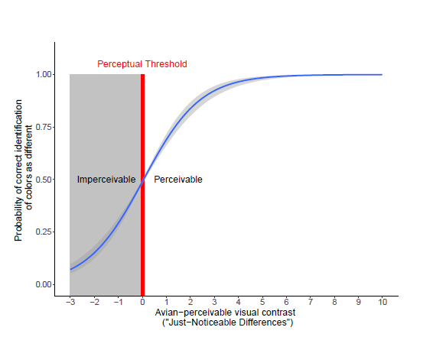
BirdVis sets an avian ‘just perceivable’ visual contrast level at 0. This means a pattern/glass combination with a
VCL value > 0 is determined to be sufficiently visible to birds (perceivable), while VCL values ≤ 0 indicate the pattern will likely not be seen against the glass by birds (unperceivable). Contrast values much greater than 0 (e.g., 5 and above) are predicted to be highly visible to birds.

The BirdVis model incorporates 4 main variables:
1) the avian visual system (bird photoreceptor sensitivities + simulated “neural noise" for each photoreceptor type),
2) the reflectance of glass and pattern samples,
3) the background against which the glass sample/pattern is viewed (this is ignored in the current model; it doesn't change the model estimates much because of visual adaptation to backgrounds), and
4) the types of light illuminating the glass and glass pattern (illuminants).
The model uses three illuminants: Midday sunlight (or Daylight, "D65, the international CIE-standard illuminant for average midday sunlight. cf Schanda, 2007), Blue Sky, and Forest Shade (Endler, 1993). The calculated avian visual contrast values are the mean of visual models across a handful of passerine species using all three illuminants (every bird visual system + illuminant combination is modeled). We can eventually change the illuminant using any light source as long as we can get absolute spectral irradiance measurements for it, meaning we could model how the glass appears at different locations and times of day.

Appendix III.

Assigning Threat Factors via Prescriptive Rating Option
All materials with assigned Threat Factors can be found here
Prescriptive Criteria for Glass with Opaque, non-metallic 2” x 2” Patterns
Bird-friendly glass assemblies that meet the following requirements are assigned a

Threat Factor of 20.
The glass assembly must have all three of the following characteristics:
I.
  - Surface one patterns only: No limit on VLR
    - Acid etch
      - Clear, low-iron, or tinted glass
      - Gloss reading of etch markers (60°) ≤ 6
or
    - Opaque frit or other opaque, non-metallic marker
      - Clear or low-iron glass

OR

  - Surface two patterns only: VLR must be ≤ 15%
    - Opaque frit or other opaque, non-metallic marker
      - Clear or low-iron glass

II. As viewed from surface 1, all low emissivity (low-E) coatings must be behind pattern.
III. A pattern of visual markers comprising one of the following marker types or a combination:
  - Continuous solid lines at least 1/8” wide (~3mm), nowhere more than 2” apart, measured edge to edge.
  - Circular, square, or irregular solid shapes that are nowhere more than 2” from the nearest shape, measured horizontally or vertically, (edge to edge) and no more than 2.83” diagonally to the nearest shape (see diagram below). Each shape must have a minimum area of ≥ 0.049 in², which corresponds approximately with circles of diameter ¼” (~6mm).
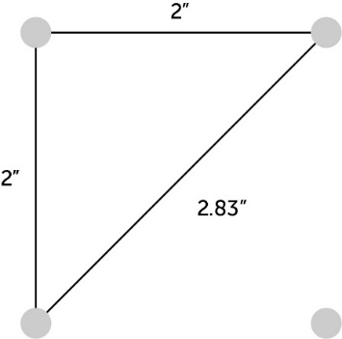
Prescriptive Criteria for Glass with Opaque, 2” x 4” Patterns
Bird-friendly glass assemblies that meet the following requirements are assigned a

Threat Factor of 25.
The glass assembly must have all three of the following characteristics:

I.
  - Surface one patterns only: No limit on VLR
    - Acid etch
      - Clear, low-iron, or tinted glass
      - Gloss reading of etch markers (60°) ≤ 6
or
    - Opaque frit or other non-metallic, opaque marker
      - Clear or low-iron glass

OR

  - Surface two patterns only: VLR must be ≤ 15%
    - Opaque frit or other non-metallic, opaque marker
      - Clear or low-iron glass

II. As viewed from surface one, all low emissivity (low-E) coatings must be behind pattern.
III. A pattern of visual markers comprising one of the following marker types or a
combination:
  - Continuous solid lines at least 1/8” wide (~3mm), nowhere more than 2” apart for horizontal or angled lines, 4” for vertical lines, measured edge to edge.
  - Circular, square, or irregular solid shapes that are nowhere more than 2” from the nearest shape vertically and nowhere more than 4” from the nearest shape horizontally, or 4.47” to the nearest shape diagonally, measured edge to edge (see diagram below). Each shape must have an area of ≥ 0.049 in², which corresponds approximately with circles of diameter ¼” (~6mm).

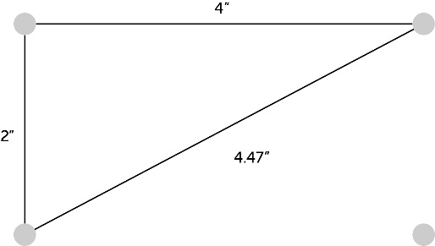

Prescriptive Criteria for Glass with Opaque < 2” Patterns
Bird-friendly glass assemblies that meet the following requirements are assigned a

Threat Factor of 25.
The glass assembly must have all three of the following characteristics:

I.
  - Surface one patterns only: No limit on VLR
    - Acid etch
      - Clear, low-iron, or tinted glass
      - Gloss reading of etch markers (60°) ≤ 6
or
    - Opaque frit or other opaque, non-metallic marker
      - Clear or low-iron glass

OR

  - Surface two patterns only: VLR must be ≤ 15%
    - Opaque frit or other opaque, non-metallic markers
      - Clear or low-iron glass

II. As viewed from surface one, all low emissivity (low-E) coatings must be behind pattern.
III. A pattern of visual markers comprising one of the following elements or a combination:
  - Continuous solid lines at least ¼” wide and spacing equivalent to line width, measured edge to edge, up to < 2”.
  - Circular, square, or irregular, solid shapes with spacing between shapes no less than diameter of pattern’s visual markers and no more than 2”, measured edge to edge. Each shape must have a minimum area of ≥ 0.049 in², which corresponds approximately with circles of diameter ¼” (~6mm).

Prescriptive Criteria for Façade Materials without Patterns
-including Spandrel Glass-
Glass builds and Façade Materials that meet the following requirements are assigned a

Threat Factor of 25

I. Surface one is continuous acid-etch with a gloss reading (60°) ≤ 16.
II. Surface is stainless steel, ASTM finish 2B or 4.

References

Cassey P, Honza M, Grim T, & Hauber ME. 2008. The modelling of avian visual perception predicts behavioural rejection responses to foreign egg colours. Biology Letters 4(5):515-7. https://doi.org/10.1098/rsbl.2008.0279
Caves EM, Brandley NC, Johnsen S. 2018. Visual acuity and the evolution of signals. Trends in Ecology & Evolution 33(5):358-72. https://doi.org/10.1016/j.tree.2018.03.00
Caves, Eleanor M. and Sönke Johnsen. 2017. AcuityView: An R package for portraying the effects of visual acuity on scenes observed by an animal. Methods in Ecology and Evolution 9(3):793-7. https://doi.org/10.1111/2041-210X.12911
Chadwick AC, Kentridge RW. 2015. The perception of gloss: A review. Vision research 109:221-35. https://doi.org/10.1016/j.visres.2014.10.026
Endler JA. The color of light in forests and its implications. 1993. Ecological monographs 63(1):1-27. https://doi.org/10.2307/2937121.
Luro, Alec B. 2021. BirdVis 1.0.0. Bird-Safe Buildings Alliance. http://3.140.67.204:3838/.
Luro AB, Fernández-Juricic E, Baumhardt P, Hauber ME. Visual acuity and egg spatial chromatic contrast predict egg rejection behavior of American robins. 2020. Journal of Experimental Biology 223(20):jeb229609. https://doi.org/10.1242/jeb.229609
Ros IG, Bhagavatula PS, Lin HT, Biewener AA. 2017. Rules to fly by: pigeons navigating horizontal obstacles limit steering by selecting gaps most aligned to their flight direction. Interface Focus 7(1):20160093. https://doi.org/10.1098/rsfs.2016.0093
Thomas RJ, Kelly DJ, Goodship NM. 2004. Eye design in birds and visual constraints on behavior. Ornitologia Neotropical 15(suppl):243-50.
Schanda, J. (Ed.). 2007. Colorimetry: understanding the CIE system. John Wiley & Sons. Hoboken, New Jersey, USA.

